



# Charles Christopher Hyland

# 450411920



# **Table of Content**

**Section 1: Data Understanding**

Section 1.1: Data Exploration

Section 1.2: Data Quality Verification

**Section 2: Data Preparation**

Section 2.1: Data Selection

 Section 2.2: Data Preparation

# **Data Understanding**

## Data Exploration

**Data Exploration Report**

The data comes in as a tabular format, which contains 12 attributes.

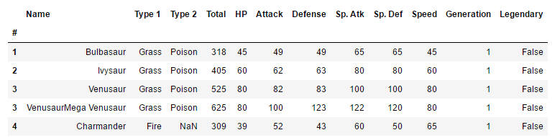

Fig. 3 Snapshot of sample of data.

Here, in a snapshot of the data, we can see it is organized in a table format. Furthermore, if a Pokémon does not have a second type, then NaN is used in place. The “Legendary” attribute return False if the Pokémon is not a legendary type Pokémon and returns True if it does.

The variables present in the data and its respective type is as follow:

|  |  |
| --- | --- |
| **Variable** | **Type** |
| Type 1 | String |
| Type 2 | String |
| Total | Numeric |
| HP | Numeric |
| Attack | Numeric |
| Defence | Numeric |
| Special Attack | Numeric |
| Special Defence | Numeric |
| Speed | Numeric |
| Generation | Numeric |
| Legendary | Boolean |

**Fig 4. List of variables**

The binary variable of Legendary will have to be converted into a numerical binary format (0 for False and 1 for True) to make data manipulation easier. Generation is coded as a numeric range from 1-6, where each number indicates a different region.

The attributes that seem most promising from the data in terms of using to classify Pokémon are:

* Attack
* Defence
* Special Attack
* Special Defence
* Speed

The generation (the region in which the Pokémon comes from) of the Pokémon currently seems irrelevant. However, it may be the case that Pokémon of a certain type from a particular region, has a combination of features which differ to Pokémon of the same type in other regions.

 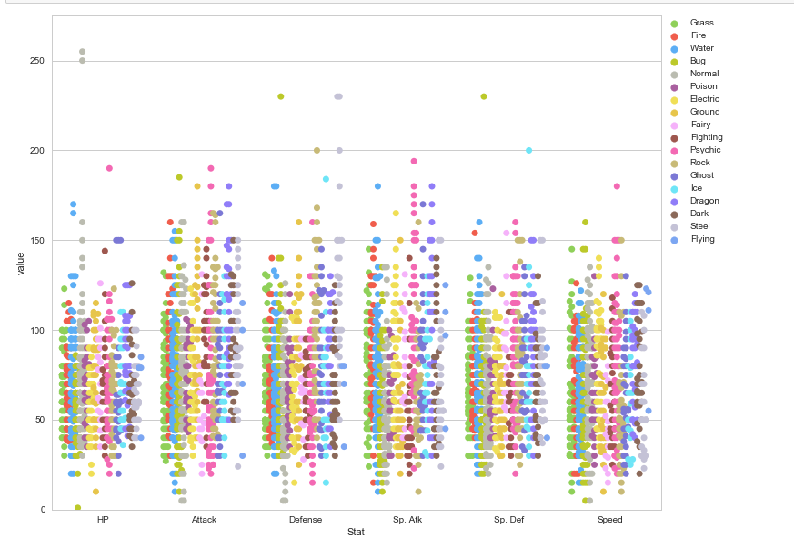

Additionally, we can see the count of each primary type of a Pokémon through a frequency table.

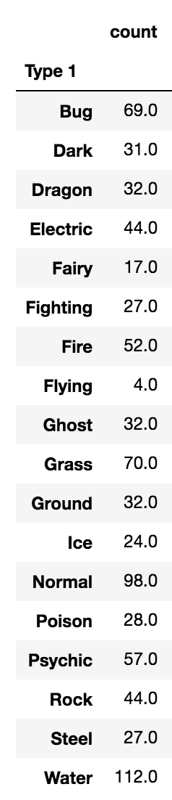

From this, it is evident that water type Pokémon are the most frequent Pokémon with over 112 instances whilst normal type Pokémon is the second most frequent. Additionally primary flying type Pokémon appears to be the rarest Pokémon. This was an unexpected result as there were many cases of Pokémon posessing wings and “flying-type” attack moves such as fly. Further investigation into this led us to then analyse that in addition to the primary type of a Pokémon, does the Pokémon also posses a secondary type? The result from this question is seen in the next table:

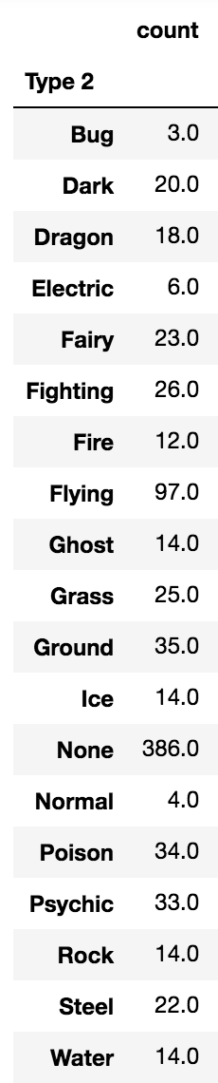

Here, flying type is the most common Pokémon’s secondary type, excluding the fact that most Pokémon seem to not have a secondary type. This solves our earlier conundrum with regards to the apparent infrequency of flying type Pokémon. We can then formulate that most Pokémon tend to be of a primary type with the added secondary type of being able to fly.



**Amount of data**

Having a large data set ensures a more accurate model and gives us more information. However, the drawback to this is that the processing time with Python will be longer due to the polynomial complexity of many algorithms to be implemented in the model.

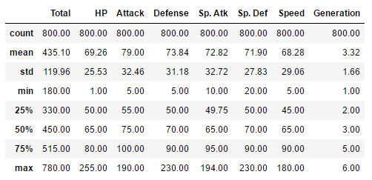

**Fig 5. Summary statistics of the data**

We can also noticed that the mean is greater than the median for the attributes of the Pokémon, thereby suggesting that the distribution of such variables are positively or right skewed.

Removed generation from the summary statistics as it does not make any sense to include them.

Currently, the summary statistics of the overall data does not provide us any insights into the business problem. We would be able to derive more information by breaking down the dataset by Pokémon type.

When splitting the data up by the type of Pokémon and summarizing the data based on certain variables, a few noticeable results appeared:

|  |  |  |  |  |
| --- | --- | --- | --- | --- |
| **Variable** | **Maximum** | **Type** | **Minimum** | **Type** |
| Attack | 112.13 | Dragon | 70.97 | Bug |
| Defence | 126.37 | Steel | 65.71 | Fairy |
| Special Attack | 96.84 | Dragon | 53.87 | Bug |
| Special Defence | 88.84 | Dragon | 62.75 | Ground |
| Speed | 102.5 | Flying | 55.26 | Steel |

From this, it appears that certain Pokémon types are associated with certain characteristics and due to the discrepancies between the maximum and minimum value for each type, it is worthwhile to assume that different types of Pokémon have unique attributes associated with them. From this, we are able to proceed with the business question and makes it worthwhile to further examine this trend.

Additionally, we need to alter the categorical column of generation as it currently suggests there is ordinality for the generation column, which again does not make sense as a Pokémon from generation 5 is not “better” than a Pokémon from generation 1. Therefore, we need to encode dummy variables into the model indicating which generation is the Pokémon a part of and then remove the original generation column. The results of such actions looks as follows:

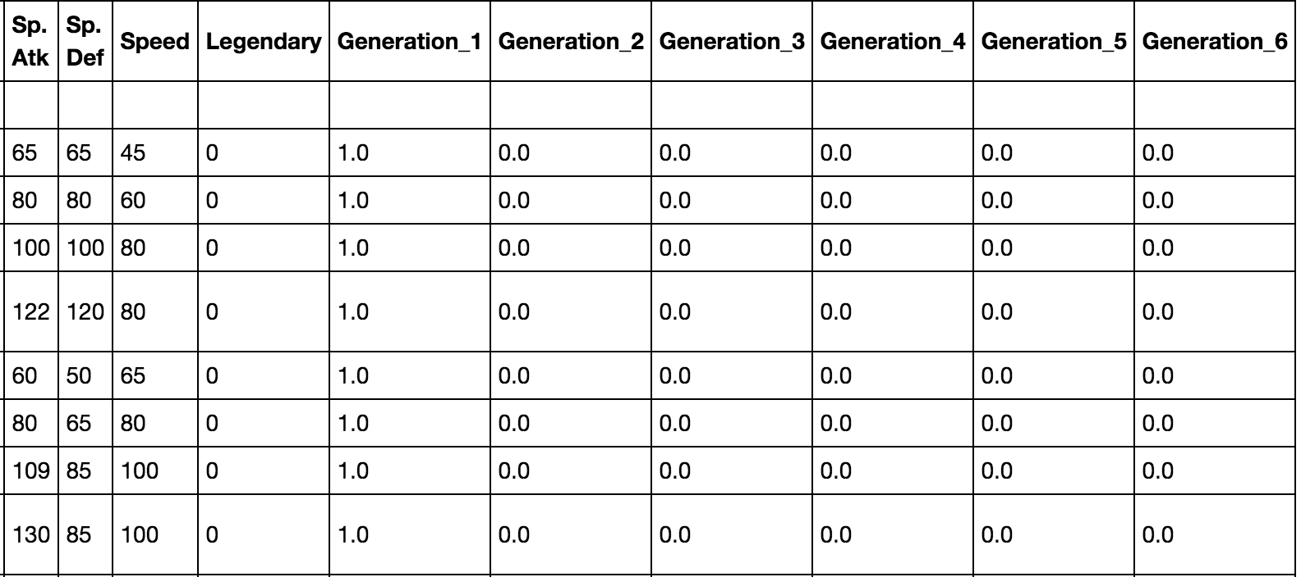

With the

## Data Verification Report

**Data Quality Report**

# Data Preparation

**Data Selection**

**Data Cleansing**

**Data Construction**

**Data Integration**

**Data Formatting**

**Dataset Description**

## Data Understanding

**Collecting Initial Data**

The data comes from existing data scraped over numerous websites via APIs. No other data is required for the project at this stage.

Currently, there are 800 observations from a cross-sectional dataset. From this it appears that the data allows us to draw generalizable conclusions and also assists us in making accurate predictions.

However, a possible issue is that there are not many attributes. This may be a problem as our predictions may suffer from omitted variable bias and that important predictors we could be using are not present in the data.

The data has already been merged and pre-processed. This brings into question the veracity of the data as the data has been processed by other parties and it is uncertain whether strict data processing methodology was adhered to.

Any missing value issues in the data was rectified as follows:

1. Find out the type of Pokémon it is.
2. Calculate the median of the attribute that the missing value belongs to from the rest of the Pokémon of the same type.
3. Use the median to replace the missing value.

It is worth acknowledging the flaws in this methodology, yet it is sufficient for the task at hand.